Equipment/Parts list for each function

Getting motor to just spin and controlling speed

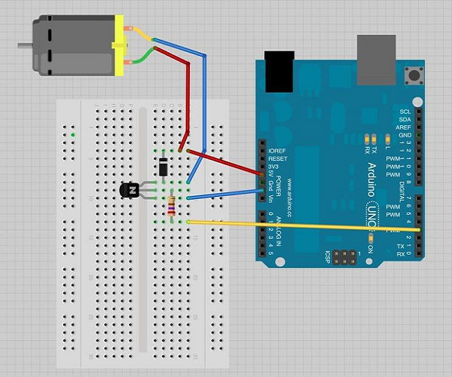

* PN2222 Transistor
* Small 6V DC motor
* N4001 diode
* 270 ohm resistor
* 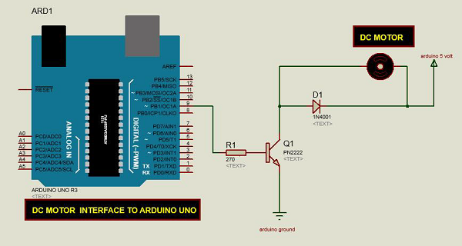

Controlling direction

* L298 Bridge IC
* Jumper wires
* 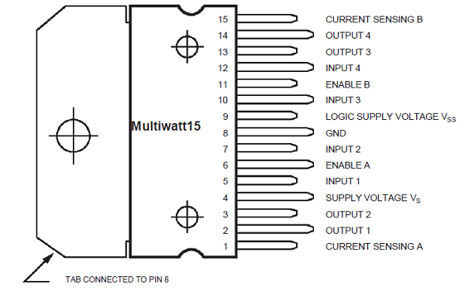
* 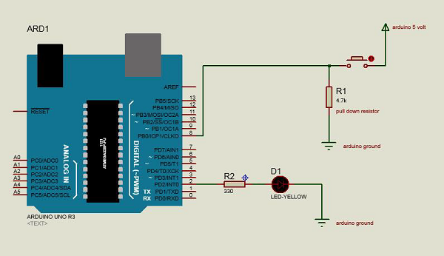

|  |  |  |
| --- | --- | --- |
| IN1 | IN2 | FUNCTION |
|  |  | BRAKE |
| 1 |  | FORWARD |
|  | 1 | BACKWARD |
| 1 | 1 | BRAKE |

Code is all done